**CHAPTER 3**

**3.1 ER DIAGRAM**

An entity–relationship model describes interrelated things of interest in a specific domain knowledge. The ER Diagram of our project is shown in the **Figure:3.1.2**

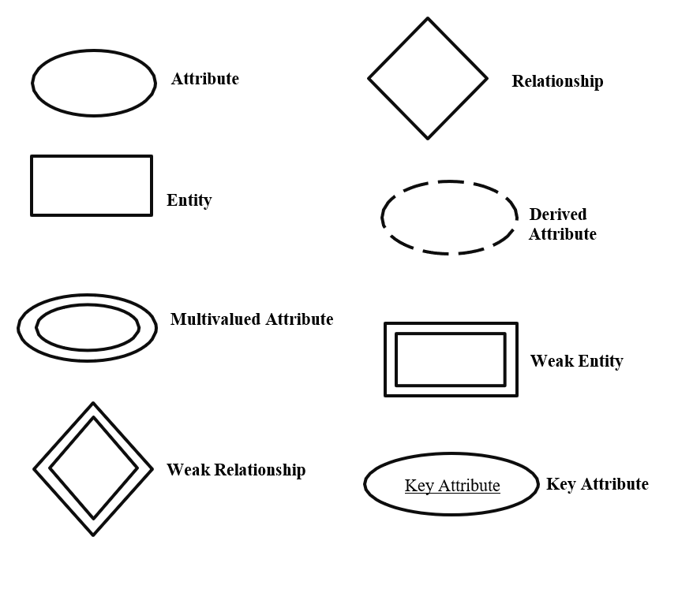

**Figure 3.1.1 : ER NOTATION**

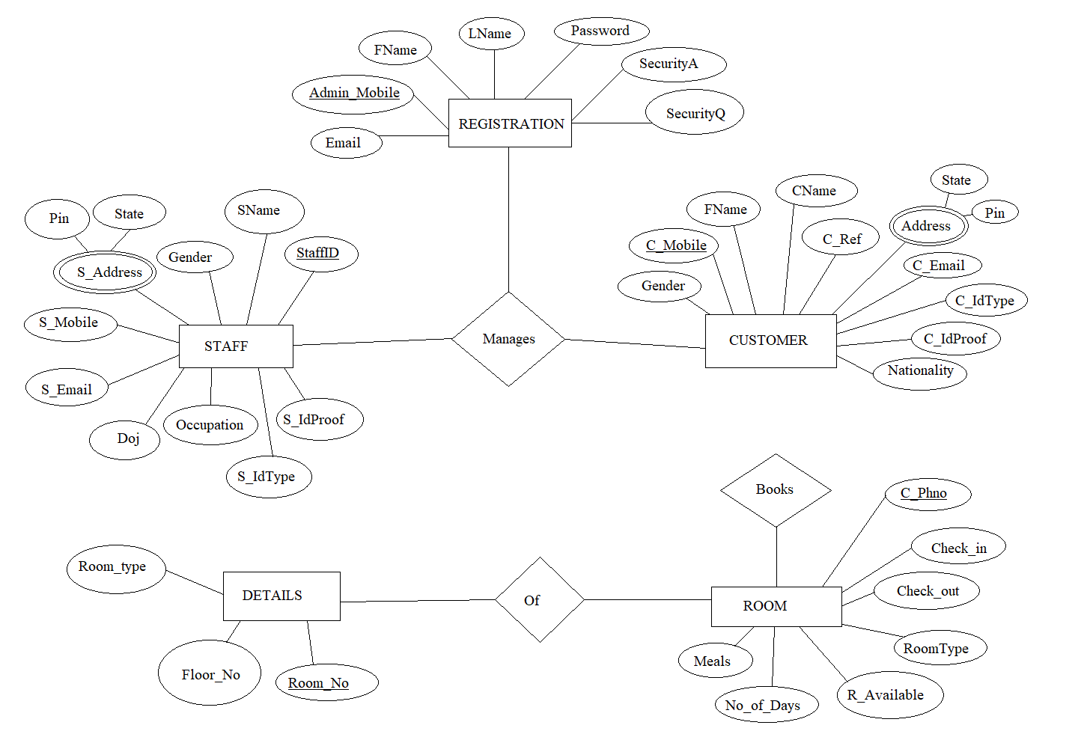

**Figure 3.1.2 : ER-Diagram of Hotel Management System**

### RELATIONAL SCHEMA

* + 1. **Mapping From ER Diagram to Schema Diagram**
       1. Mapping of regular entities:-This step involves mapping all the regular entity types to tabular format by identifying their primary keys.
       2. Mapping of 1:1 Relation:-In this step foreign keys are assigned using foreign key approach. The primary key of the participating relation R or S is added as primary key to second entity types by looking at the participating constraints.
       3. Mapping of 1:N Relation:-Foreign key approach is used to add one sided primary key to the n sided entity at foreign key.
       4. Mapping of M:N Relation :-Here we use the cross reference approach where the relationship is converted to a new relation within attributes on primary keys of both participating relation.
       5. Mapping of Weak Entity :-When mapping weak entity types along with other attributes the partial key and primary key of parent entity together will form their primary key of the new relation.
       6. Mapping of Multivalued Relation :-For multivalued attributes a separate relation has to be created along with primary key of parent relation. A relational schema for a database is an outline of how data is organized.
       7. Mapping of N-ary Relation:-For mapping N ary relationship we create a new relation with a relationship name in its attribute and primary keys of all participating entity types.

### STEP 1: Mapping of regular entity types.

The regular entity types of our project are shown in figure

**REGISTRATION**

|  |  |  |  |  |  |  |
| --- | --- | --- | --- | --- | --- | --- |
| Admin_Mobile | FName | LName | Email | SecurityQ | SecurityA | Password |

**CUSTOMER**

|  |  |  |  |  |  |  |  |  |  |
| --- | --- | --- | --- | --- | --- | --- | --- | --- | --- |
| C_Mobile | C_Ref | CName | FName | Gender | C_Email | Nationality | C_IdType | C_IdProof | Address |

**STAFF**

|  |  |  |  |  |  |  |  |  |  |
| --- | --- | --- | --- | --- | --- | --- | --- | --- | --- |
| StaffID | S_Mobile | SName | Doj | Gender | C_Email | Occupation | C_IdType | C_IdProof | Address |

**ROOM**

|  |  |  |  |  |  |  |
| --- | --- | --- | --- | --- | --- | --- |
| C_Phno | Check_in | Check_out | Room_Type | R_Available | Meals | No_of_Days |

**DETAILS**

|  |  |  |
| --- | --- | --- |
| Room_No | Floor_No | Room_type |

**Fig 3.2.1: Mapping of Regular Entity types**

**STEP 2: Mapping of weak entity types**

The ERD of our project doesn’t contain weak entity

**STEP 3: Mapping of binary 1:1 relation types**

The ERD of our project does not contain any 1:1 relation types.

**STEP 4: Mapping of 1: N relation types**

For every 1:N relation types identify the entity which is in the N-side. Make primary key of entity which is participating in 1 side as foreign key of entity which is N-side. If there are any attributes for the relationship add to the N-side.

The ERD of our project 1:N relation type is shown below

**REGISTRATION**

|  |  |  |  |  |  |  |
| --- | --- | --- | --- | --- | --- | --- |
| Admin_Mobile | FName | LName | Email | SecurityQ | SecurityA | Password |

**CUSTOMER**

|  |  |  |  |  |  |  |  |  |  |
| --- | --- | --- | --- | --- | --- | --- | --- | --- | --- |
| C_Mobile | C_Ref | CName | FName | Gender | C_Email | Nationality | C_IdType | C_IdProof | Address |

**STAFF**

|  |  |  |  |  |  |  |  |  |  |
| --- | --- | --- | --- | --- | --- | --- | --- | --- | --- |
| StaffID | S_Mobile | SName | Doj | Gender | C_Email | Occupation | C_IdType | C_IdProof | Address |

**ROOM**

|  |  |  |  |  |  |  |
| --- | --- | --- | --- | --- | --- | --- |
| C_Phno | Check_in | Check_out | Room_Type | R_Available | Meals | No_of_Days |

**Fig 3.2.2 : Mapping of 1:N Relation types**

**STEP 5: Mapping of M: N relation types**

The ERD of our project M:N relation type is shown below

**OF**

|  |  |
| --- | --- |
| Room_No | C_Phno |

**Fig 3.2.3 : Mapping of M:N Relation types**

**STEP 6: Mapping of multivalued attributes**

The ERD of our project multivalued attributes is shown below

**STAFF_ADDRESS**

|  |  |  |
| --- | --- | --- |
| StaffID | State | Pincode |

**CUSTOMER_ADDRESS**

|  |  |  |
| --- | --- | --- |
| C_Mobile | State | Pincode |

**Fig 3.2.4 : Mapping of multivalued attributes**

**STEP 7: Mapping of n-ary relation types**

The ERD of our N-ary relation is shown below.

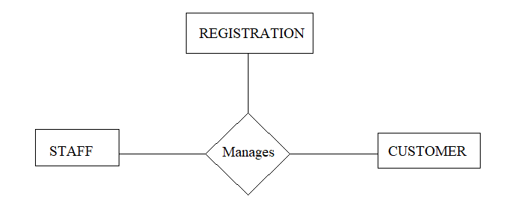

**MANAGES**

|  |  |  |
| --- | --- | --- |
| C_Mobile | Admin_Mobile | StaffID |

**Fig 3.2.5 : Mapping of N-ary Relation types**

* 1. **SCHEMA DIAGRAM**

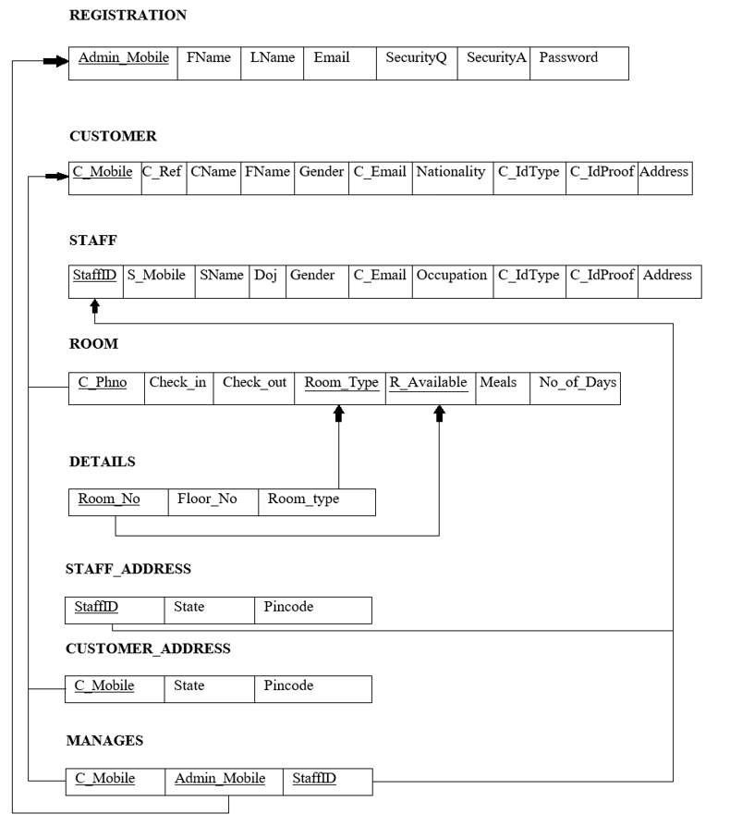

**Fig 3.2.6 : Schema Diagram for Hotel Management System**